Chapter 7, Solution 54.

- Before t = 0, i is obtained by current division or
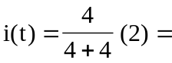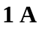
After t = 0,
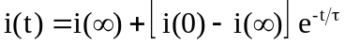
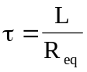, 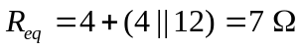
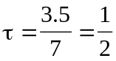
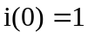, 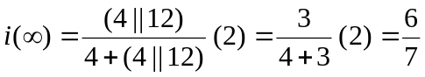
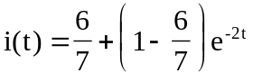
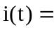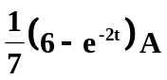
(b) Before t = 0, 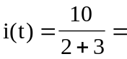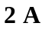
After t = 0, 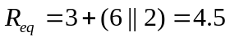
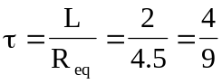
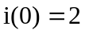
To find 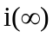, consider the circuit below, at t = when the inductor becomes a short circuit,

+
−

+
−
3 
6 
24 V
2 
10 V
v
i
2 H

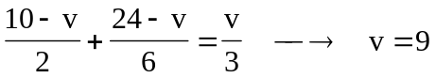 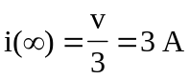 and 